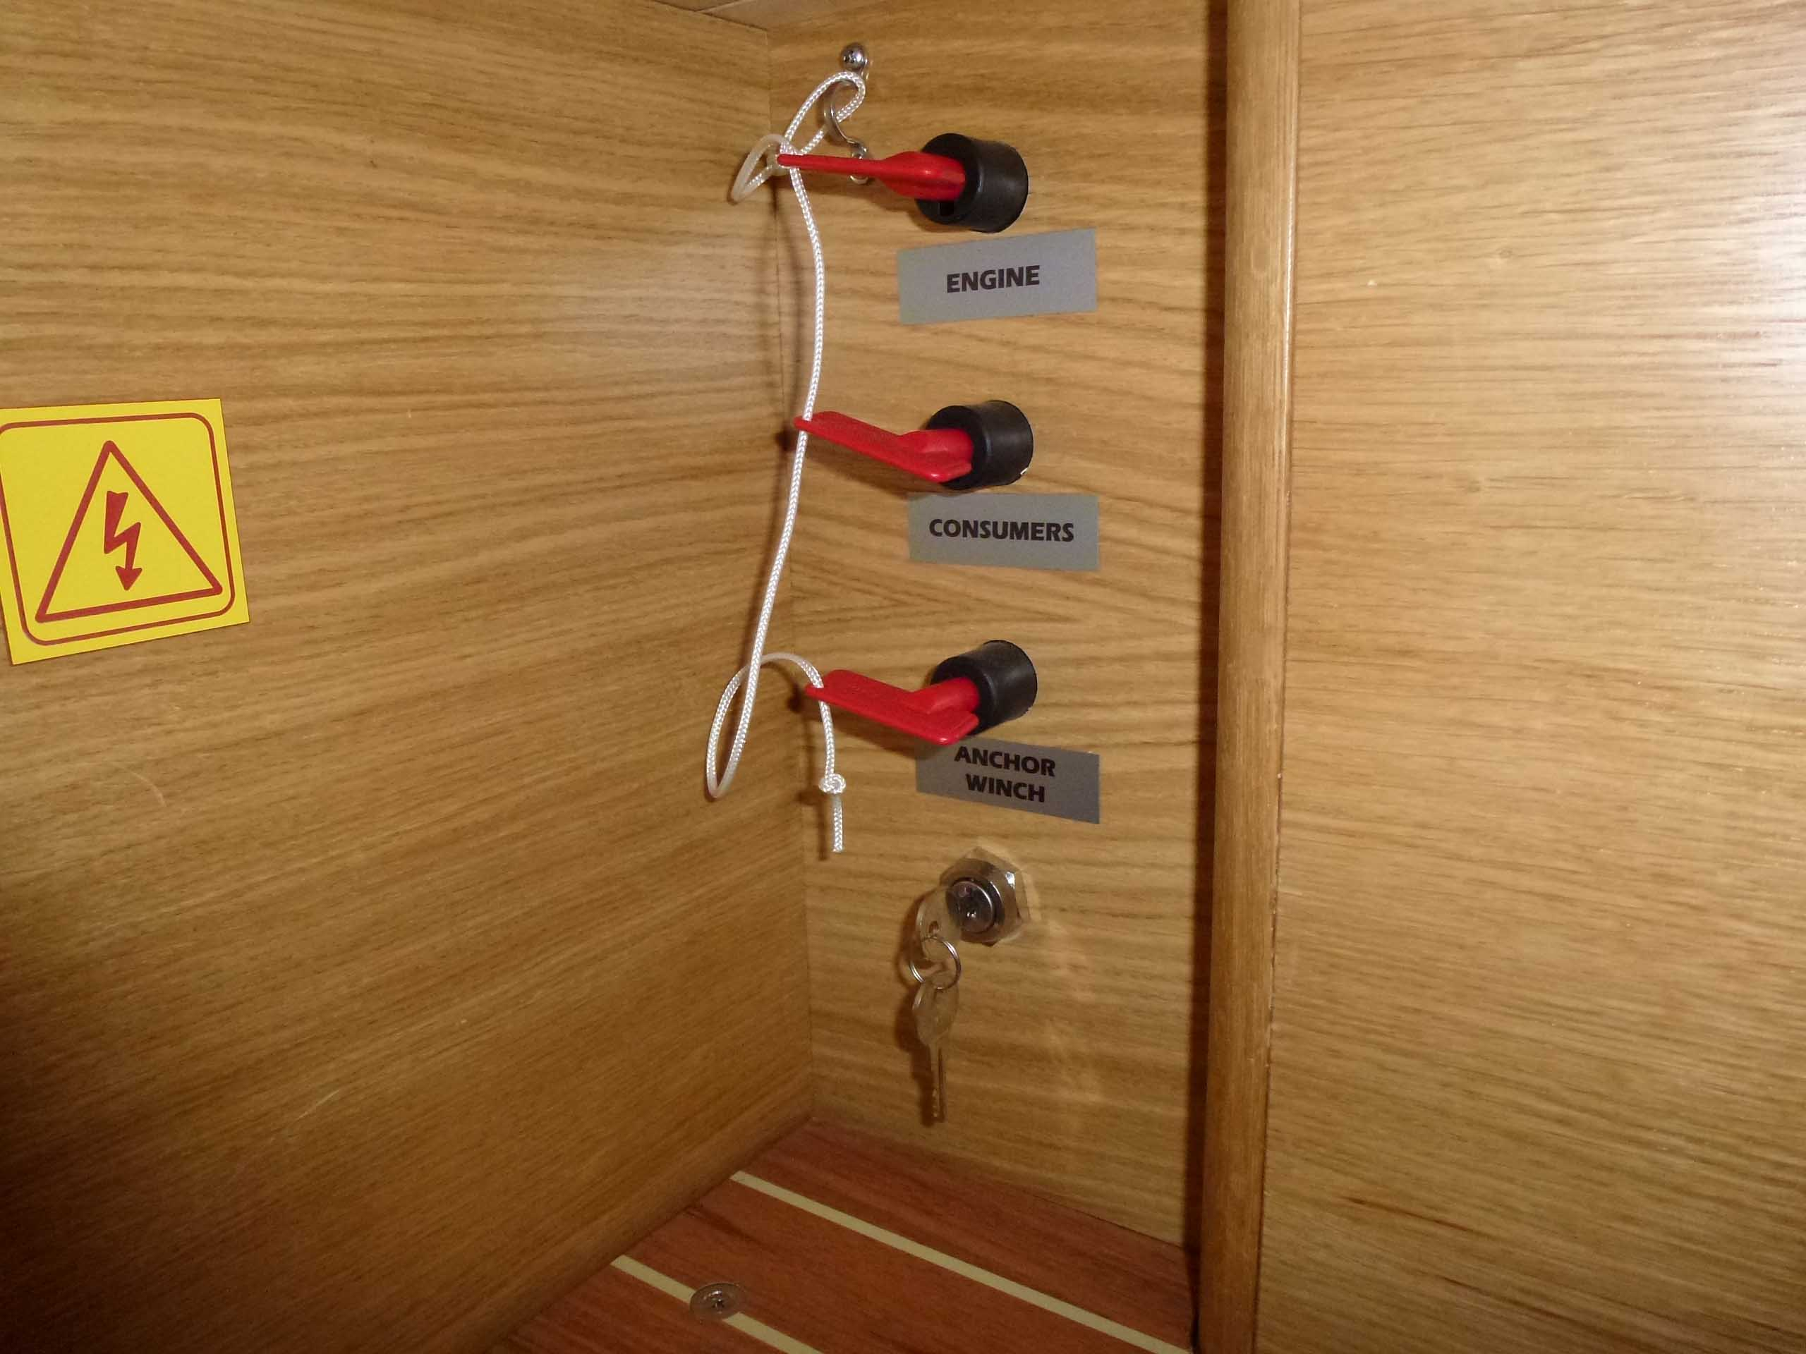
Preparing the diesel for running
- Turn on the red isolator switch labeled Engine in the Starboard aft cabin - see photo 1 at right.
- Open the engine compartment and visually check the engine for loose components and any signs of water, fuel or oil leaks.
- Check the engine oil level. Fill if necessary.
- Check the Saildrive oil level. Fill if necessary. Take care not cross thread dip stick
- Check the engine coolant level. Fill if necessary.
- Check the cooling water skimmer filter on the aft wall of the engine bay. Clean if necessary.
- Check the 4 fuel supply cocks are open. Under floor, forward of stairs
- Open the seawater cooling inlet seacock. It is located forward of the engine under the stairs.
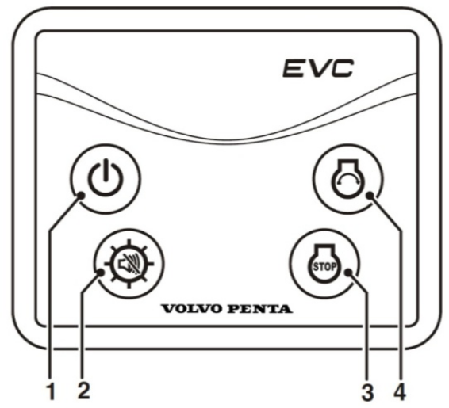
To start the diesel
- Check no swimmers near the yacht and no ropes near the propeller.
- Move the engine control lever to the neutral position.
- On the Cockpit motor control panel press the top left button 1 to energise the controller panel. You should see “Volvo Penta” in LED display panel
- Press the top right button 4 to start the motor
- Check for cooling water flow from the outlet under the starboard quarter. If no flow after 15 seconds stop the engine and investigate.
- Allow the engine to warm up at a fast idle speed for a few minutes before leaving the marina berth.
- Button 2 adjusts the screen brightness.
- Check on the Xantrex battery monitor that the generator is charging the batteries.

To stop the diesel
- Allow the engine to idle in neutral for a few minutes before stopping.
- On the Cockpit motor control panel press the bottom right button 3 to stop the motor
- Turn off the top left button 1 when the motor stops. LED display panel will shut down indicating power is off.
- When sailing with motor off, click the gear shift into reverse to feather the propeller and stop it rotating.

- If closing up the boat: Turn off the red engine isolator switch.
- If closing up the boat: Close the cooling water seacock.

Emergency start
- To bypass the cockpit engine control panel if it is not working, use the bypass key switch in the Starboard aft cabin under the red isolator switches shown in Photo 1 on previous page.

Emergency stop
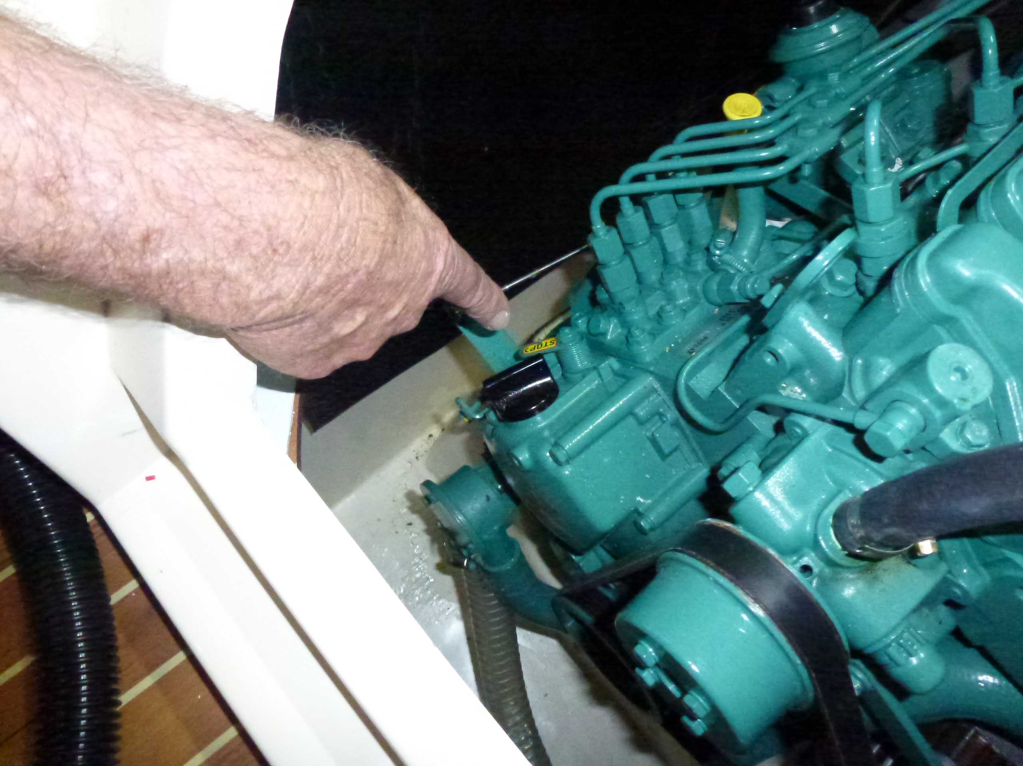
- To manually stop the motor if the cockpit engine control panel is not working, use the manual stop lever on the engine shown in photo at right. Push lever aft to stop.

Notes and Capacities
- Diesel fuel capacity 230 Litres
- Alternator generates 90 Amp effective when re-charging the batteries at 12 Volt.
- Optimal engine speed is 1850 Revs/Minute. This uses about 3.5 Litres/hour.
- The propeller rotates ANTI-CLOCKWISE from the perspective of a person facing forwards in the boat. If any prop walk is experienced, it would be to port in forward gear.
- Engine Oil is 20W/50 with a 10.5 Litre capacity.
- S-Drive Oil is 15W/40 with a 3 Litre capacity.

